**Brandon Hobbs**

**CS-360**

**February 19, 2023**

**Project 3: Writing Prompt**

Launching a new app in the market is all about timing, features, and filling a gap that other app makers have left open. Looking through the app market with an eye for competitive analysis there are few other simple weight tracking apps; however, the top returns have a few limitations that this app will bypass to allow it to be competitive in this space.

“Simple Weight Tracker” and “Weight Tracker” were analyzed and both greet the user with a small summary table showing actual weight, change, the weekly trend, this week’s and this’s months change, and the total weight change. “Weight Tracker” adds prediction ability (trying to predict when the goal will be reached), time spent on the user journey, and track BMI.

Neither of these apps appear to allow multiple users to track their goals and weight not do they have any protection on the data – which will be the selling point of this app over its closest rivals. Moreover, the two apps analyzed and many other available apps only target users wanting to lose weight. This app will not make that assumption.

To make this app standout the description will need to play up its strengths - especially since the other apps have been in the market longer so are more mature. Highlighting the differences, a discussion around the user protections, multiple users, and SMS notifications would be warranted. The icon also needs to illustrate the main purpose well.

Most competitive apps are using some sort of scale, measurement, or plot iconography. And while it would be good to try and stand apart from these other apps, it is also important that the selected icon be descriptive of the use, identifiable, and recognizable. Because of this I, too, would choose a scale, but a more stylized version than the generic bathroom scale icon most other are used. For example, this (Fig. 1) might be more whimsical and catch someone’s eye in the market.



**Figure 1: A More Whimsical Scale Icon**

Targeting the latest version of the Android API is attractive. It brings features, techniques, and security not available in earlier version. However, if using API features not available in previous versions then the app has alienated potential users. Figure 2 (Composables, 2023) shows the latest data from the Google dev channels of the API worldwide distribution.

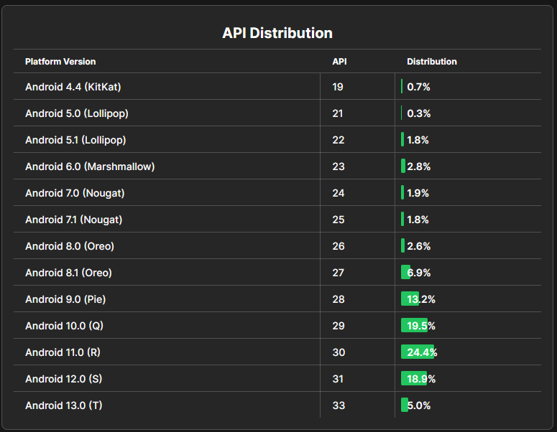

**Figure 2: Android Distribution Chart**

This chart tends to suggest that an API level no more recent than 29 should be used. An API level of 29 encompasses 67.8% of the market. 28 could also be targeted a that would bring the potential market to 81% of all handhelds. Targeting the latest API reduces the market to 5%.

Another important decision to make during design is what OS features and permissions will be required. The more permissions needed the richer the features but some users may not like giving access to the more sensitive sensors and data, e.g., contacts, camera, microphone, etc. Currently, the only permission needed for this app is the ability to text, which most users will probably not take umbrage with as it is fairly obvious what data is being sent, i.e., SMS text messages would be visible in the SMS app. Moreover, this is a user defeatable feature which could add comfort to those more sensitive users.

This app is simple and therefore any wish to generate revenue also demands a simple approach. There is a lot of open space in the footer section of the app. Small ads could be placed here. Or, perhaps having a user watch an add every 5th time they record a weight entry. The app could also use freemium techniques. For example, the ability to set a goal could be unlocked for a nominal payment. SMS notifications could be a upsell. Or, the app could be purchased with all features and no ads for a fee. In the end, taking a “all-roads” approach may be best – embed ads in the free version of the app but have a feature to remove the ads for a fee.

These ads could also be targeted. For those users setting goals lower than their average weight, ads targeting weight loss would be warranted. Or, those users trying to gain weight could be targeted with supplements and weight training regimen.

This plan would need to be monitored to see which stream was generating the greatest revenue. If the revenue was lopsided in favor of one method, then perhaps the other method should be eliminated.

Composables. (2023, January 6th). *Android distribution chart*. https://www.composables.com/

tools/distribution-chart